Q10.Explain the architecture of JVM

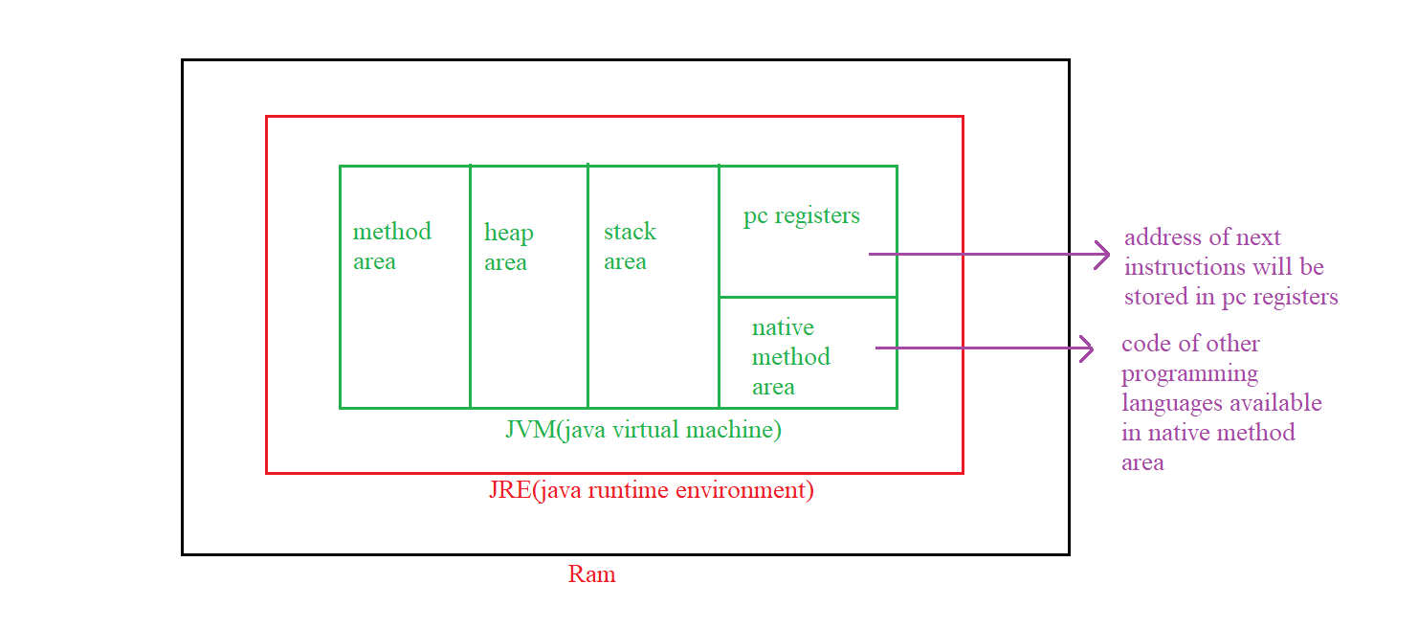

Method Area: stores the .class files, static variables and their values which are of primitive and compile time constants

Heap Area: stores objects and instance variables

Stack Area: local variables and method calls are stored in stack

Pc registers: address of next instruction which have to be executed

Native Method Area: stores the code of other programming languages which useful for java